AWS Application Migration Service (MGN) is a highly automated lift-and-shift (rehost) solution that simplifies, expedites, and reduces the cost of migrating applications to AWS.

It enables companies to Rehost large number of physical, virtual, or cloud servers without compatibility issues, performance disruption, or long cutover windows.

AWS MGN provides similar capabilities as [CloudEndure Migration](https://console.cloudendure.com/#/register/register), but is available on the AWS Management Console. This enables seamless integration with other AWS services, such as AWS CloudTrail, Amazon CloudWatch, and AWS Identity and Access Management (IAM).

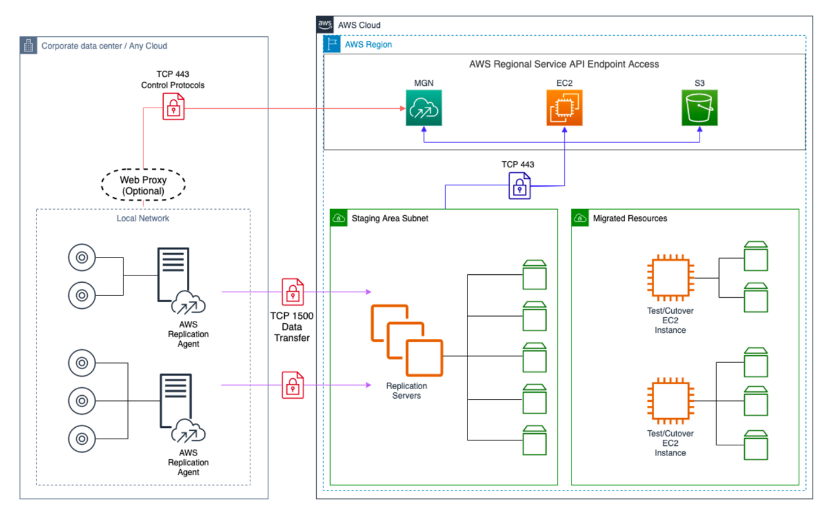

We can connect from Source datacenter to data plane i.e staging area subnet in destination VPC over private connection using VPN, DirectConnect or VPC peering in MGN as well as CloudEndure .

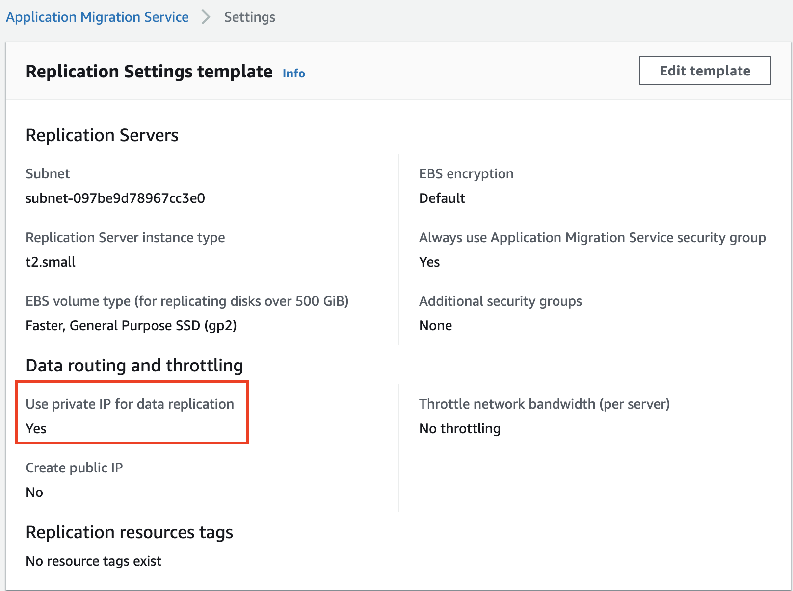

MGN enables additional facility to leverage [interface VPC endpoint](https://docs.aws.amazon.com/vpc/latest/userguide/vpce-interface.html#create-interface-endpoint.html) powered by AWS PrivateLink to connect MGN control plane over private network

This pattern aims at helping customers connect to MGN control plane on a private secured network

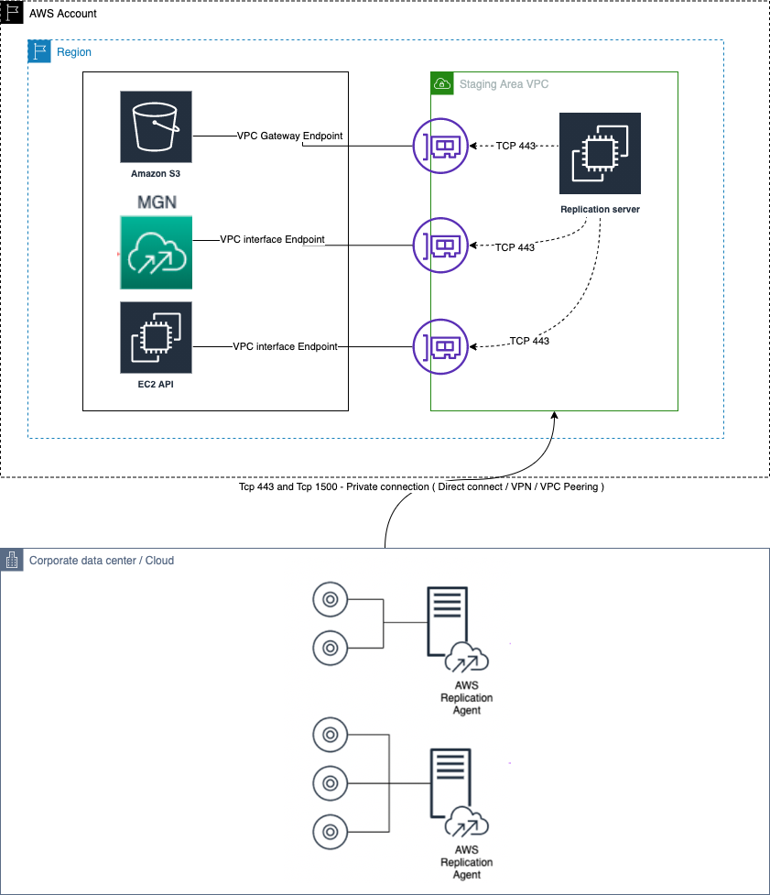



## Create a VPC endpoint interface

An interface VPC endpoint enables you to connect to services powered by AWS PrivateLink. These services include some AWS services, services hosted by other AWS customers and partners in their own VPCs also known as endpoint services.

A VPC endpoint enables you to privately connect your VPC to supported AWS services and VPC endpoint services powered by PrivateLink without requiring an internet gateway, NAT device, VPN connection, or AWS Direct Connect connection. Instances in your VPC do not require public IP addresses to communicate with resources in the service. Traffic between your VPC and the other service does not leave the Amazon network.

## Prerequisite for this demo:

**Staging Area Subnet**

Before setting up Application Migration Service you should *create a subnet which will be used by Application Migration Service as a staging area for data replicated from your source servers to AWS*. You must specify this subnet in the Replication Settings template. You can override this subnet for specific source servers in the Replication Settings. While you can use an existing subnet in your AWS account, the best practice is to create a new dedicated subnet for this purpose. [Learn more about Replication Settings.](https://docs.aws.amazon.com/mgn/latest/ug/replication-settings-template.html)

## Network requirements

The *Replication Servers* launched by Application Migration Service in your Staging Area Subnet *need to be able to send data over TCP port 443 to the Application Migration Service API endpoint* at https://mgn.{region}.amazonaws.com/. Replace “{region}” with the AWS Region code you are replicating to, for example “us-east-1” .

The *source servers* on which the AWS Replication Agent is installed *need be able to send data over TCP port 1500 to the Replication Servers* in the Staging Area Subnet. They also need to be able to send data to Application Migration Service's API endpoint at https://mgn.{region}.amazonaws.com/. Replace “{region}” with the AWS Region code you are replicating to, for example “us-east-1” .

<https://docs.aws.amazon.com/mgn/latest/ug/Network-Requirements.html>

## VPC with a private subnet with EC2 instance hosted inside it.

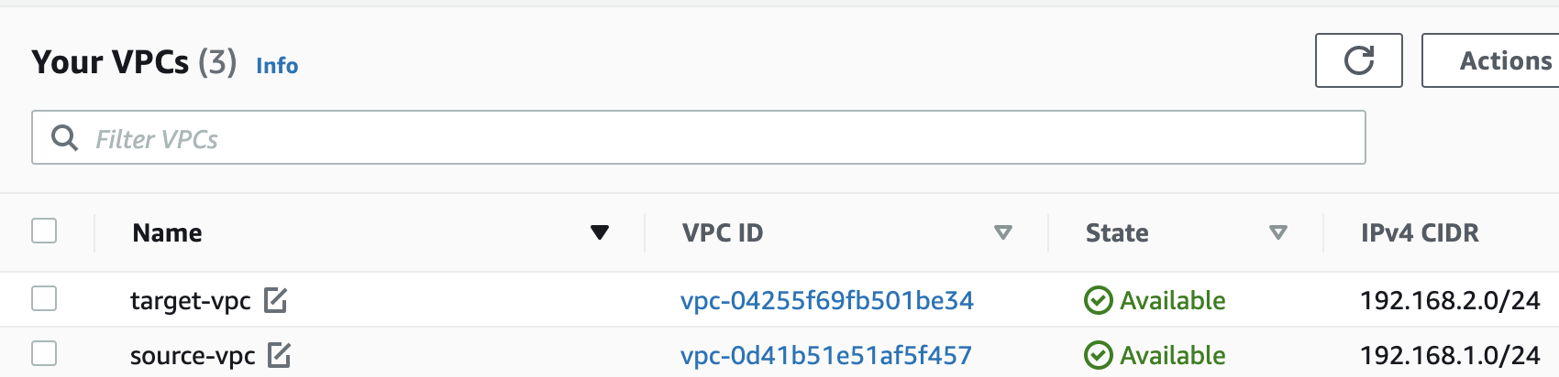

## Subnets

# 

## EC2

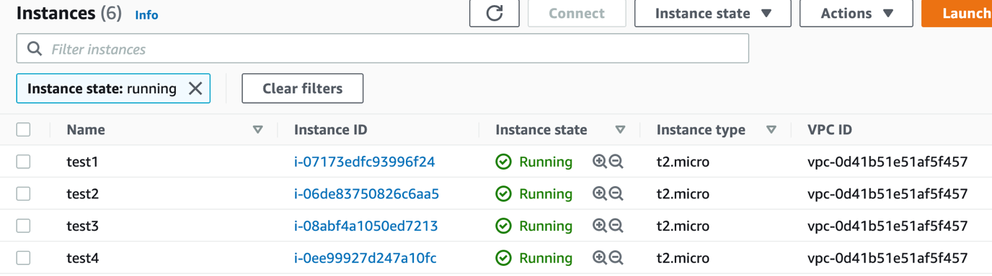

## Step 1: Login to AWS console and navigate to ‘VPC’.

## Step 2: Navigate to ‘Endpoints’ and click ‘Create Endpoint’ in target VPC. Source Datacenter ( Source-VPC in this demo) would connect privately to Application Migration service control plane via Interface endpoints created in Target VPC

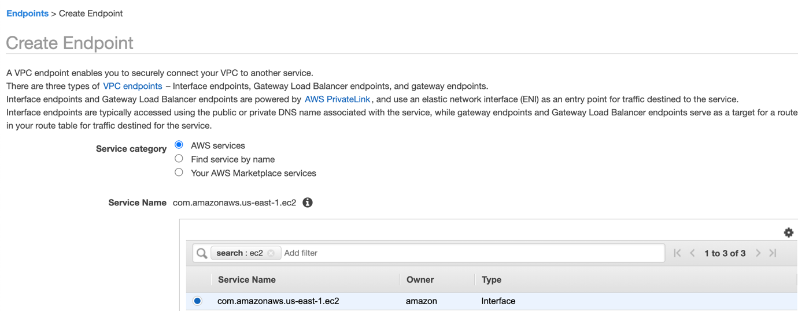

Select VPC , Subnets to create endpoint and also enable DNS name for endpoint.

Create a Security group to allow TCP 443 from VPC subnet

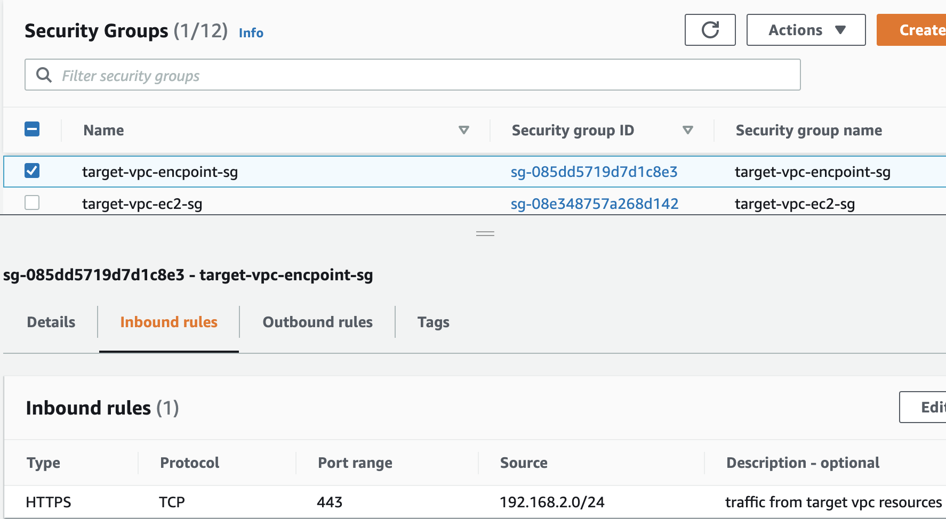

# 

Similarly create endpoints for mgn and S3

# 

Our EC2 instances still does not have internet access as shown below in route tables associated to target-vpc subnets

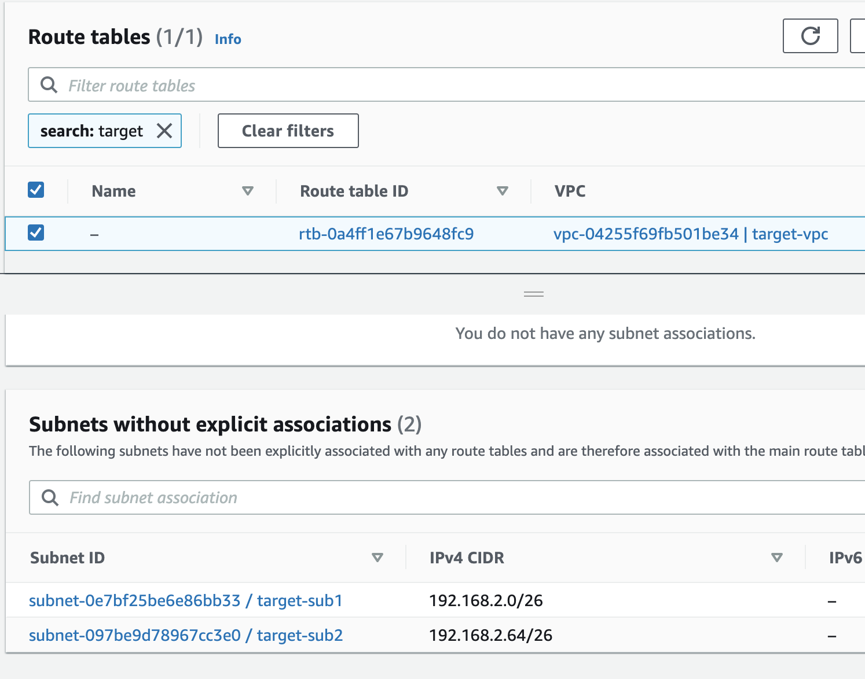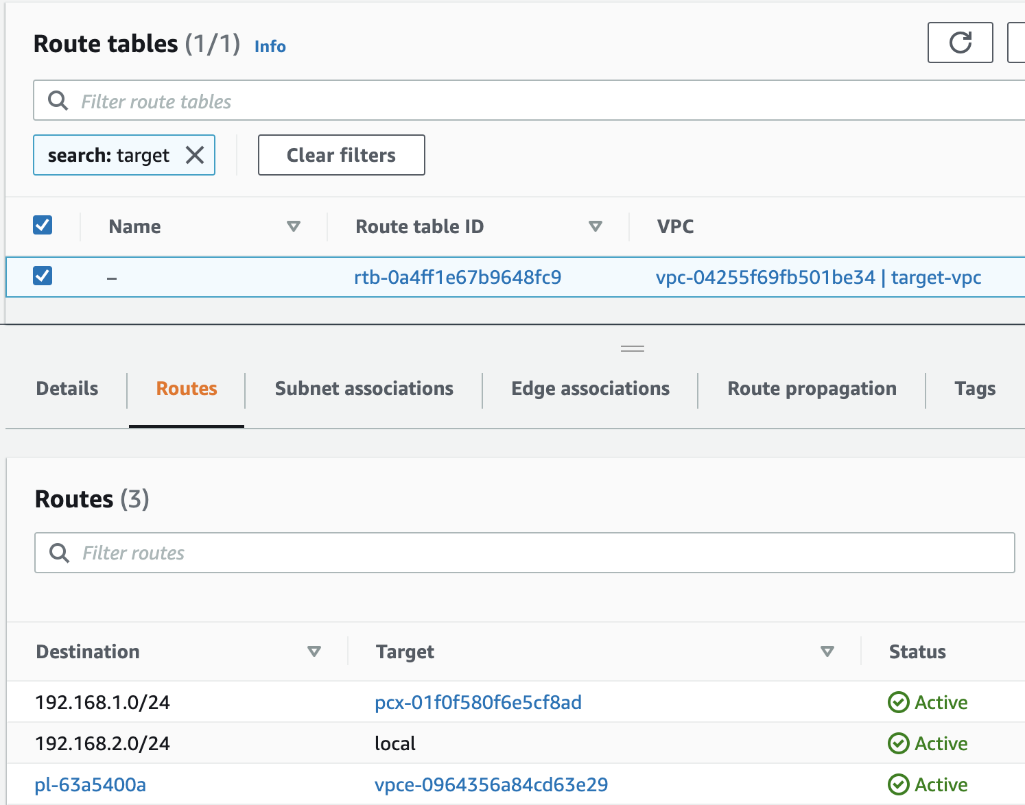

Login to source servers ( ec2 in source-vpc in our demo) .The Application Migration Service AWS Replication Agent installer needs network access to MGN and S3 endpoints. Since our on premise network is not open to MGN and S3 endpoints, we can install the Agent with the aid of PrivateLink.

# 

Quick start guide to configure and use Application Migration Service: <https://docs.aws.amazon.com/mgn/latest/ug/quick-start-guide-gs.html>

Once agent is installed , source server would appear on Migration service console

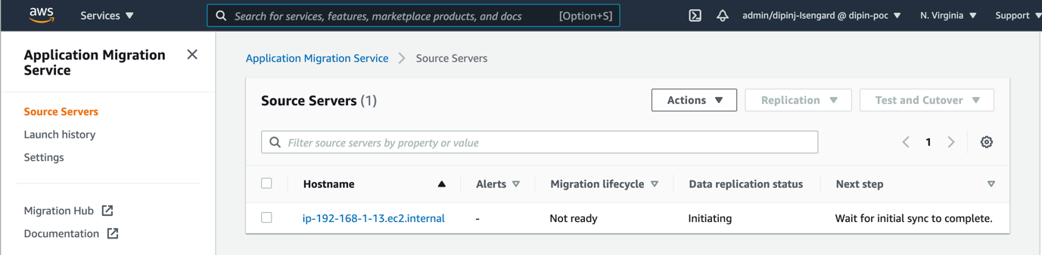

Click on server to check Replication progress

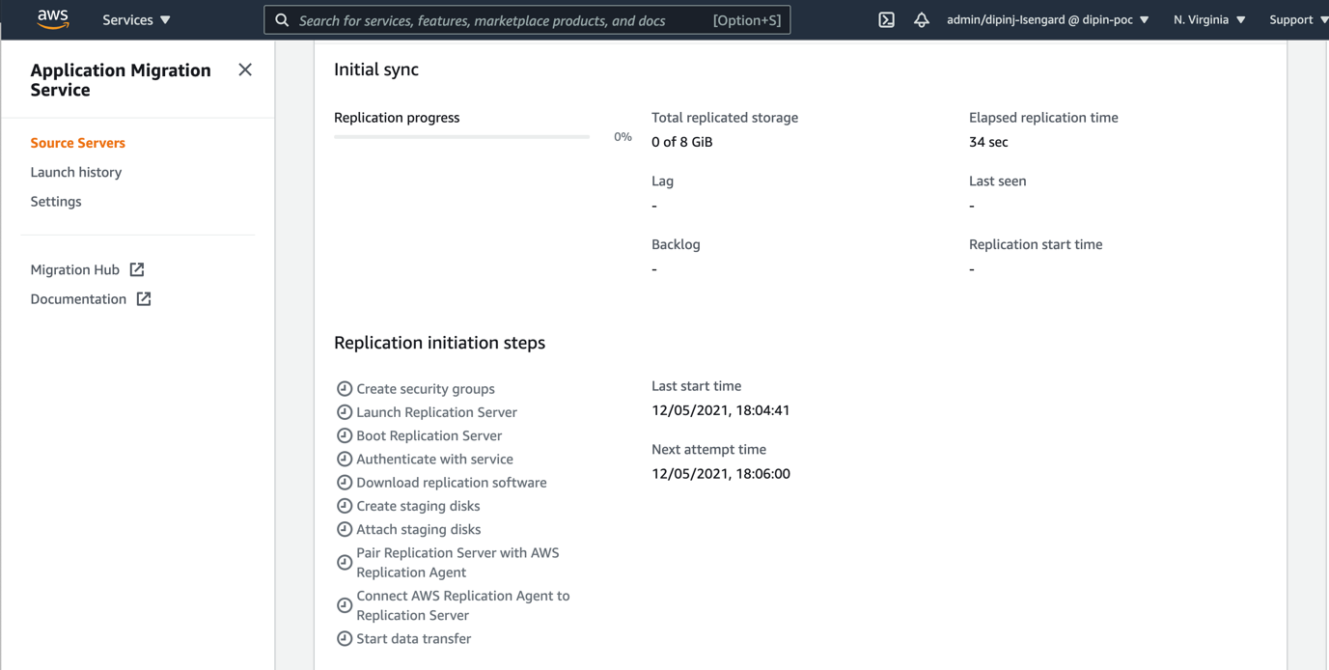

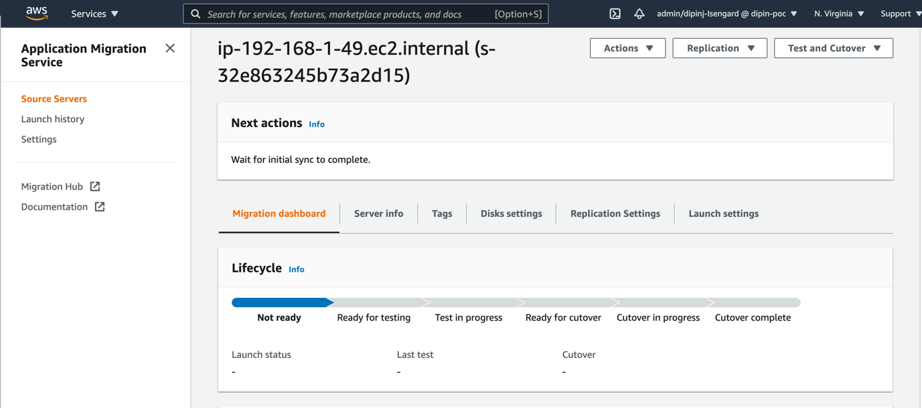

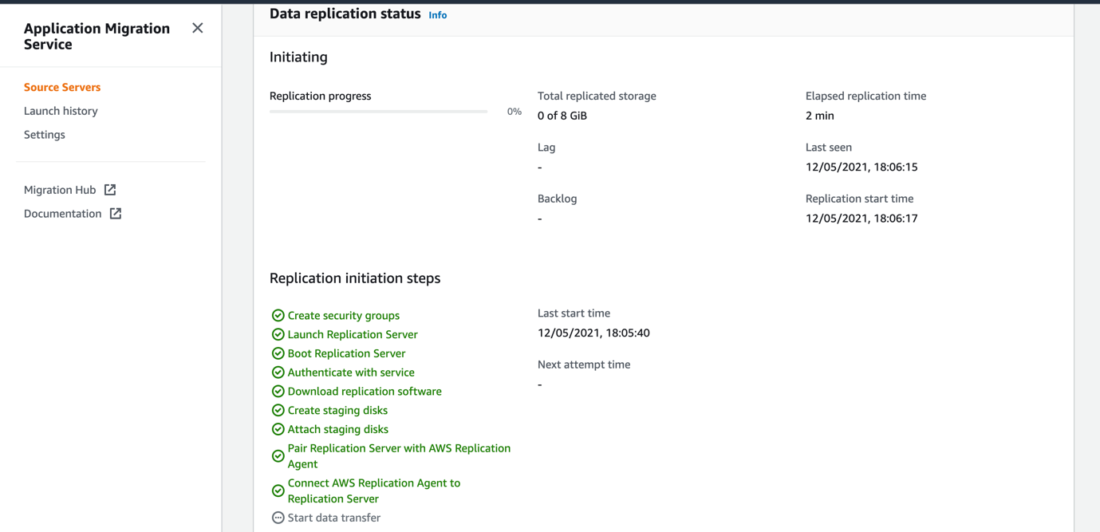

Click on Launch settings and configure destination server settings

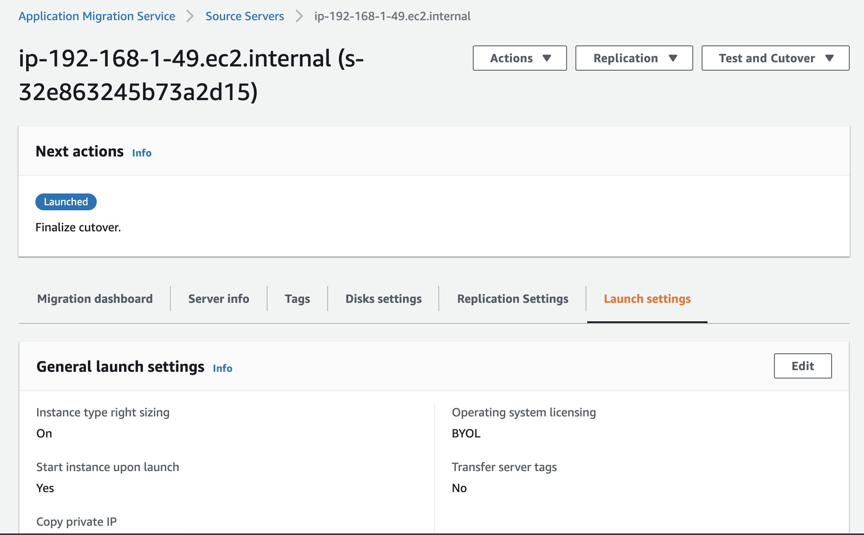

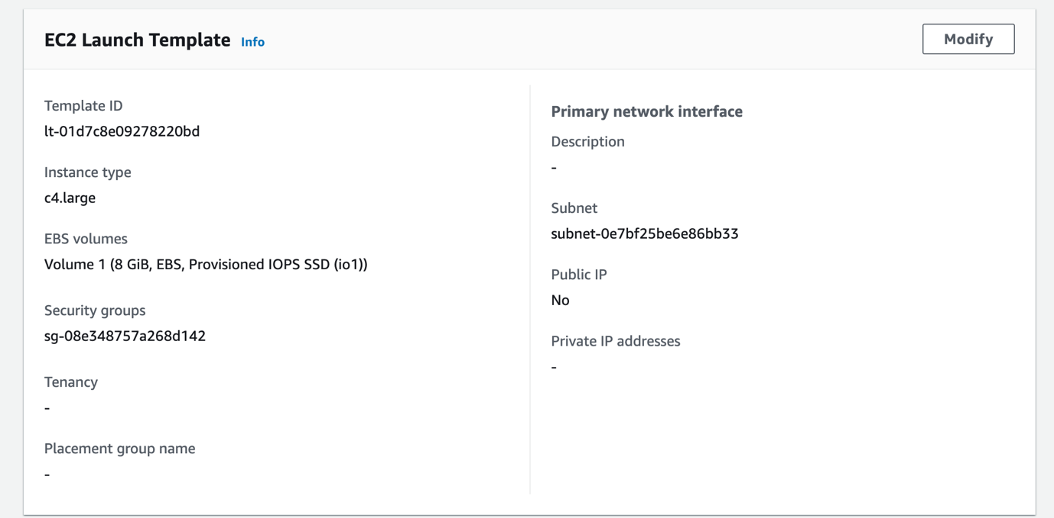

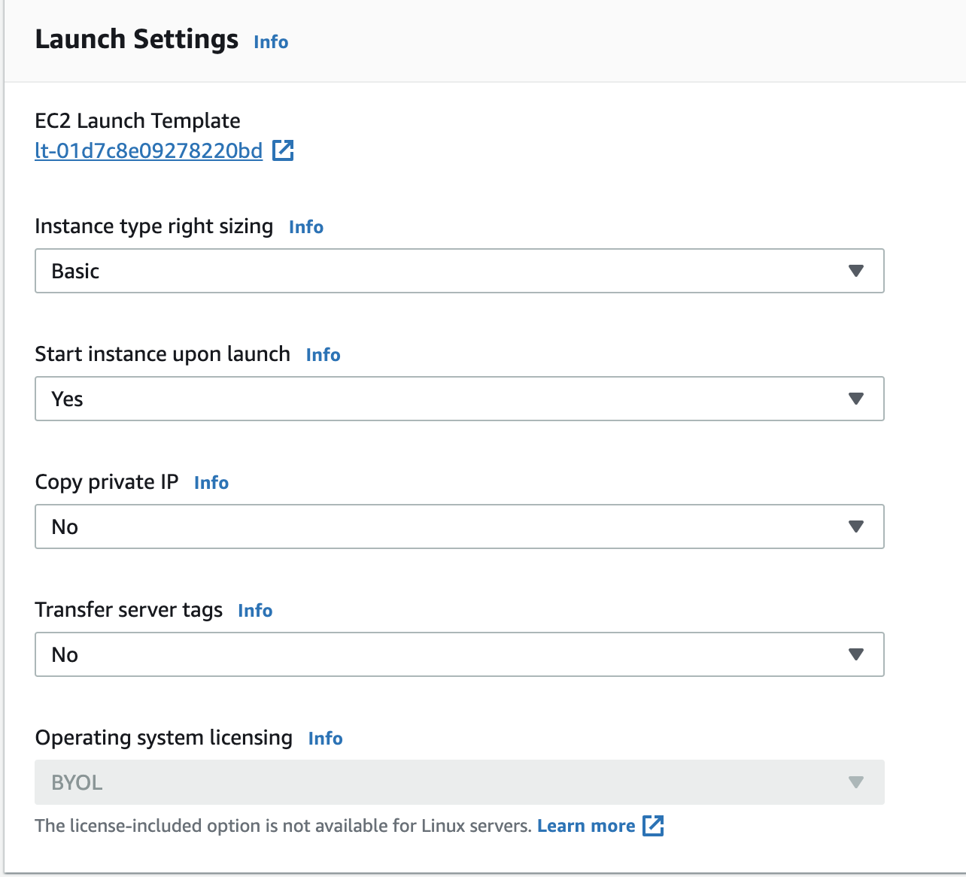

Once server replication is complete and its ready for testing /cutover , click on Test and cutover and perform Test /cutover.

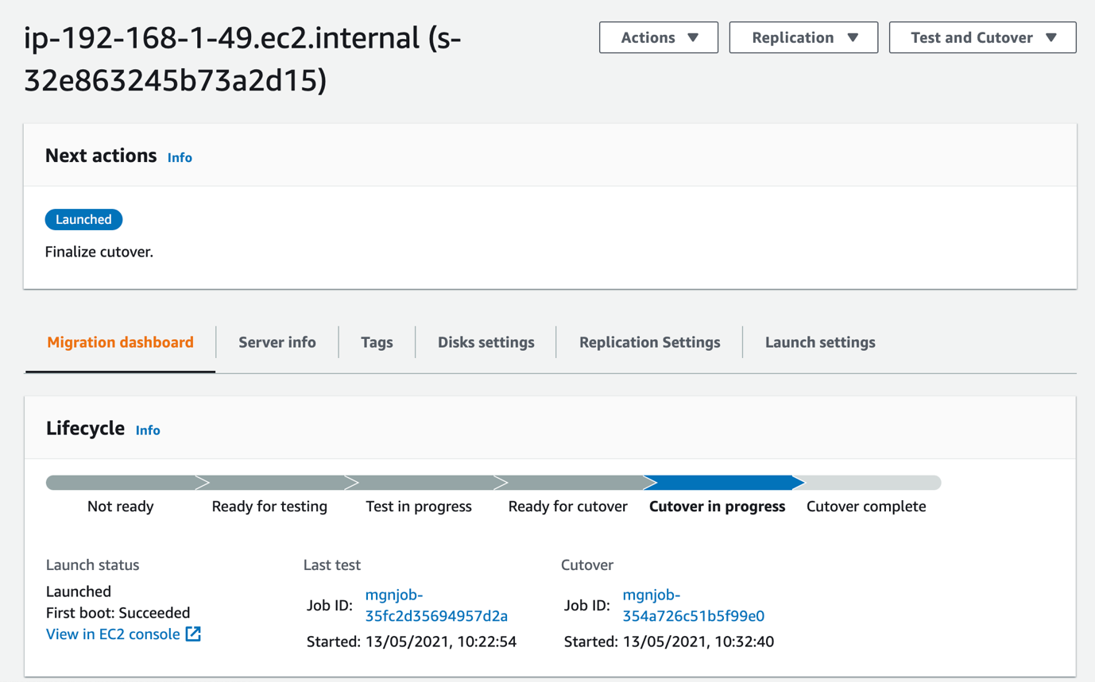

Click on Job ID to check Migration progress

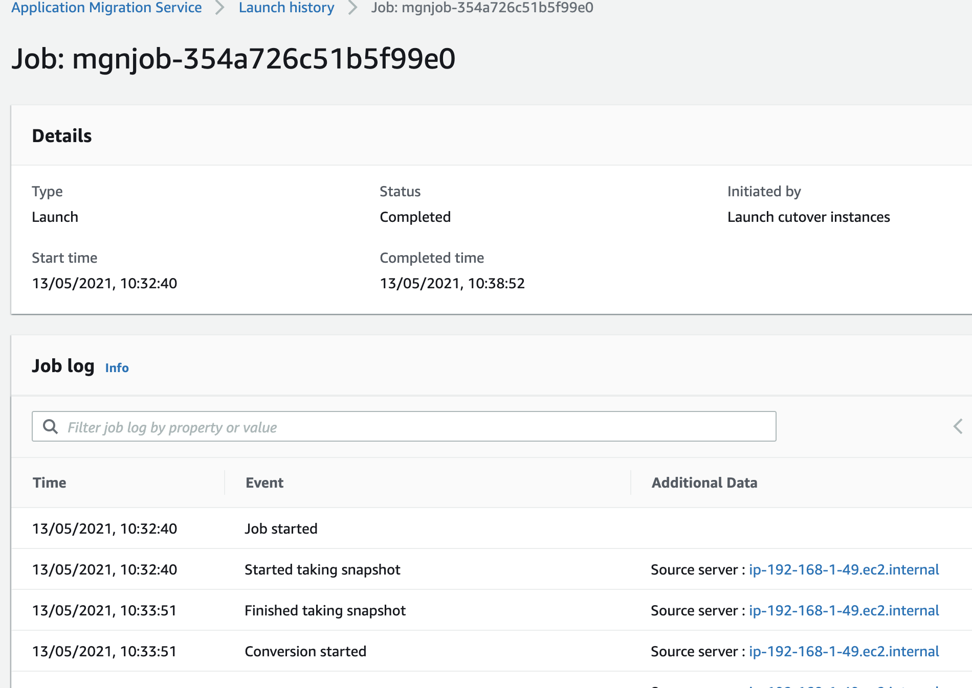

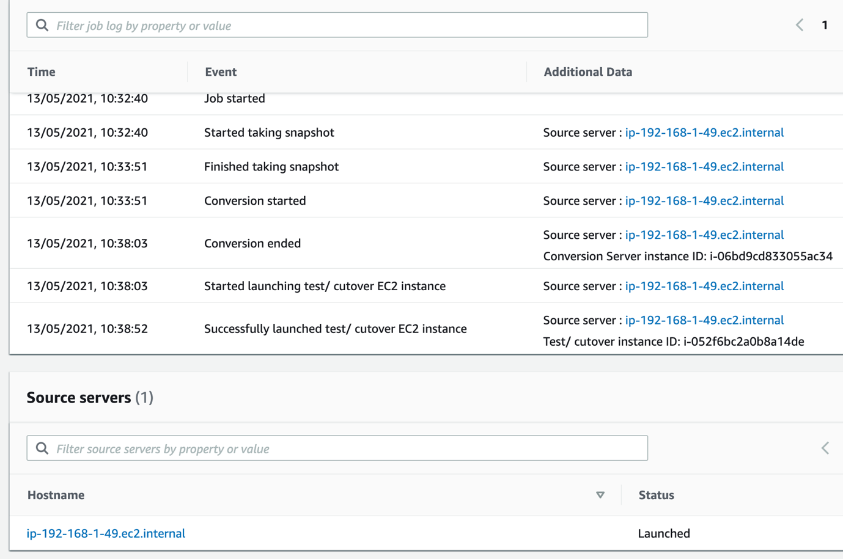



Check EC2 console to find the test/cutover EC2 instance.

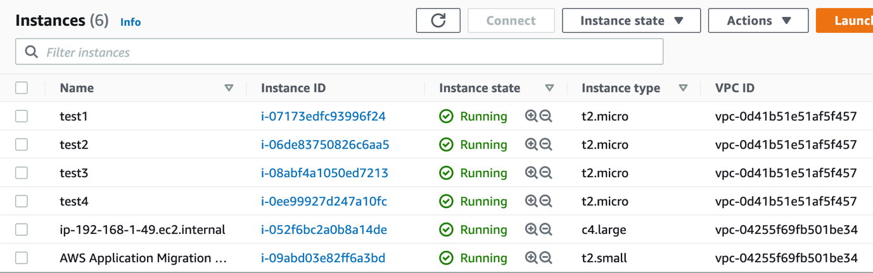



# Supported AWS Regions

# 

# MGN Technical Training Materials

[AWS Application Migration Service - A Technical Introduction](https://www.aws.training/Details/eLearning?id=71732)

<https://docs.aws.amazon.com/mgn/latest/ug/installing-agent-blocked.html>